**Week-4 – SpringRest**

**Exercise : Hello World RESTful Web Service**  
  
Write a REST service in the spring learn application created earlier, that returns the text "Hello World!!" using Spring Web Framework. Refer details below:  
  
**Method:** GET  
**URL:** /hello  
**Controller:** com.cognizant.spring-learn.controller.HelloController  
**Method Signature:** public String sayHello()  
**Method Implementation:** return hard coded string "Hello World!!"  
**Sample Request**: http://localhost:8083/hello  
**Sample Response:** Hello World!!   
  
Try the URL http://localhost:8083/hello in both chrome browser and postman.  
  
SME to explain the following aspects:

* In network tab of developer tools show the HTTP header details received
* In postman click on "Headers" tab to view the HTTP header details received

**HelloController.java :**

package com.cognizant.spring_learn2.Controller;

import org.springframework.web.bind.annotation.GetMapping;

import org.springframework.web.bind.annotation.RestController;

@RestController

public class HelloController {

@GetMapping("/hello")

public String sayHello() {

String message = "Hello World!!";

return message;

}

}

**Output :**

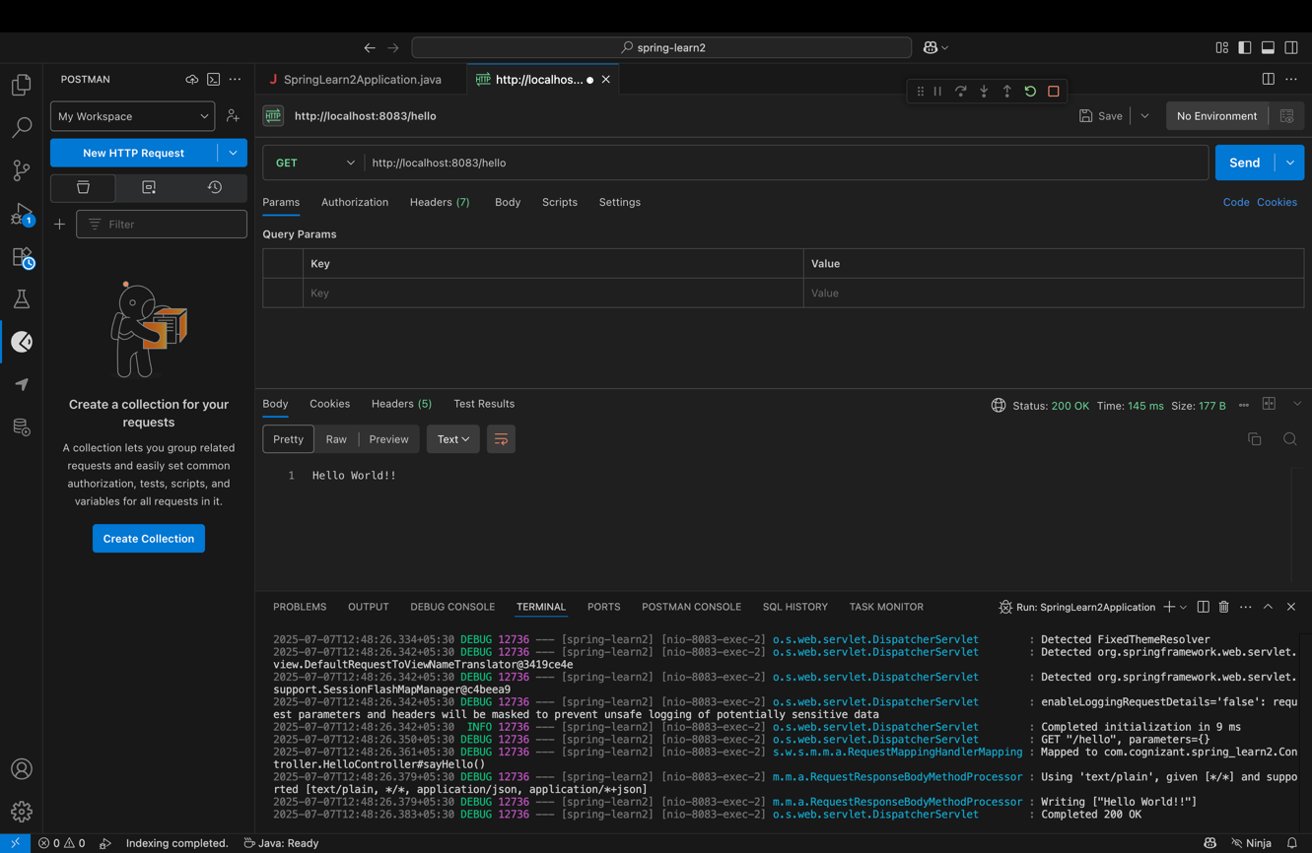

**Exercise : REST - Country Web Service**   
  
Write a REST service that returns India country details in the earlier created spring learn application.  
  
**URL**: /country  
**Controller**: com.cognizant.spring-learn.controller.CountryController  
**Method Annotation**: @RequestMapping  
**Method Name**: getCountryIndia()  
**Method Implementation**: Load India bean from spring xml configuration and return  
**Sample Request**: http://localhost:8083/country  
**Sample Response**:

{

  "code": "IN",

  "name": "India"

}

SME to explain the following aspects:

* What happens in the controller method?
* How the bean is converted into JSON reponse?
* In network tab of developer tools show the HTTP header details received
* In postman click on "Headers" tab to view the HTTP header details received

**CountryController.java :**

package com.cognizant.spring_learn2.Controller;

import com.cognizant.spring_learn2.Country;

import org.slf4j.Logger;

import org.slf4j.LoggerFactory;

import org.springframework.context.ApplicationContext;

import org.springframework.context.support.ClassPathXmlApplicationContext;

import org.springframework.web.bind.annotation.RequestMapping;

import org.springframework.web.bind.annotation.RestController;

@RestController

public class CountryController {

private static final Logger LOGGER = LoggerFactory.getLogger(CountryController.class);

@RequestMapping("/country")

public Country getCountryIndia() {

LOGGER.info("START - getCountryIndia()");

ApplicationContext context = new ClassPathXmlApplicationContext("country.xml");

Country country = context.getBean("country", Country.class);

LOGGER.info("END - getCountryIndia()");

return country;

}

}

**Country.xml :**

<?xml version="1.0" encoding="UTF-8"?>

<beans xmlns="http://www.springframework.org/schema/beans"

xmlns:xsi="http://www.w3.org/2001/XMLSchema-instance"

xsi:schemaLocation="http://www.springframework.org/schema/beans

http://www.springframework.org/schema/beans/spring-beans.xsd">

<bean id="country" class="com.cognizant.spring_learn2.Country">

<property name="code" value="IN"/>

<property name="name" value="India"/>

</bean>

</beans>

**Output :**

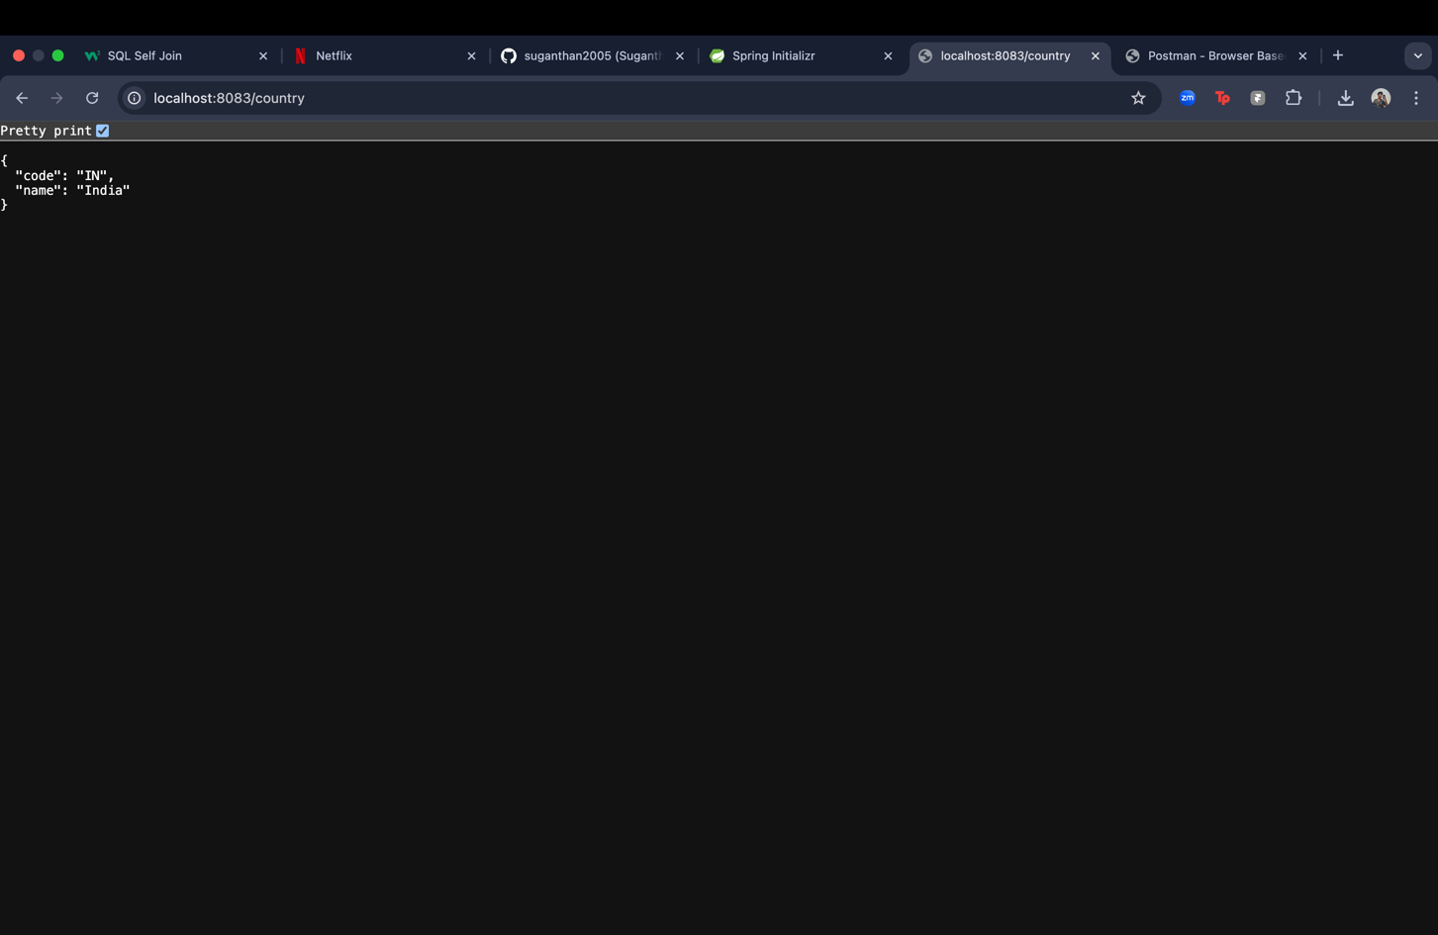

**Exercise : REST - Get country based on country code**   
  
Write a REST service that returns a specific country based on country code. The country code should be case insensitive.  
  
**Controller**: com.cognizant.spring-learn.controller.CountryController  
**Method Annotation:** @GetMapping("/countries/{code}")  
**Method Name**: getCountry(String code)  
**Method Implemetation**: Invoke countryService.getCountry(code)   
**Service Method:**com.cognizant.spring-learn.service.CountryService.getCountry(String code)  
  
**Service Method Implementation**:

* Get the country code using @PathVariable
* Get country list from country.xml
* Iterate through the country list
* Make a case insensitive matching of country code and return the country.
* Lambda expression can also be used instead of iterating the country list

**Sample Request**: http://localhost:8083/country/in  
  
**Sample Response**:

{

  "code": "IN",

  "name": "India"

}

**Country.xml ;**

<?xml version="1.0" encoding="UTF-8"?>

<beans xmlns="http://www.springframework.org/schema/beans"

xmlns:xsi="http://www.w3.org/2001/XMLSchema-instance"

xsi:schemaLocation="http://www.springframework.org/schema/beans

http://www.springframework.org/schema/beans/spring-beans.xsd">

<bean id="country" class="com.cognizant.spring_learn2.Country">

<property name="code" value="IN"/>

<property name="name" value="India"/>

</bean>

<bean id="countryList" class="java.util.ArrayList">

<constructor-arg>

<list>

<bean class="com.cognizant.spring_learn2.Country">

<property name="code" value="IN"/>

<property name="name" value="India"/>

</bean>

<bean class="com.cognizant.spring_learn2.Country">

<property name="code" value="US"/>

<property name="name" value="United States"/>

</bean>

<bean class="com.cognizant.spring_learn2.Country">

<property name="code" value="DE"/>

<property name="name" value="Germany"/>

</bean>

<bean class="com.cognizant.spring_learn2.Country">

<property name="code" value="JP"/>

<property name="name" value="Japan"/>

</bean>

</list>

</constructor-arg>

</bean>

</beans>

**Country.java :**

package com.cognizant.spring_learn2;

import org.slf4j.Logger;

import org.slf4j.LoggerFactory;

public class Country {

private static final Logger LOGGER = LoggerFactory.getLogger(Country.class);

private String code;

private String name;

public Country() {

LOGGER.debug("Inside Country Constructor.");

}

public String getCode() {

LOGGER.debug("Inside getCode()");

return code;

}

public void setCode(String code) {

LOGGER.debug("Inside setCode()");

this.code = code;

}

public String getName() {

LOGGER.debug("Inside getName()");

return name;

}

public void setName(String name) {

LOGGER.debug("Inside setName()");

this.name = name;

}

@Override

public String toString() {

return "Country [code=" + code + ", name=" + name + "]";

}

}

**CountryController.java :**

package com.cognizant.spring_learn2.Controller;

import com.cognizant.spring_learn2.Country;

import com.cognizant.spring_learn2.service.CountryService;

import org.slf4j.Logger;

import org.slf4j.LoggerFactory;

import org.springframework.beans.factory.annotation.Autowired;

import org.springframework.web.bind.annotation.*;

@RestController

public class CountryController {

private static final Logger LOGGER = LoggerFactory.getLogger(CountryController.class);

@Autowired

private CountryService countryService;

@GetMapping("/country/{code}")

public Country getCountry(@PathVariable String code) {

LOGGER.info("START - getCountry(): {}", code);

Country country = countryService.getCountry(code);

LOGGER.info("END - getCountry()");

return country;

}

}

**CountryService.java :**

package com.cognizant.spring_learn2.service;

import com.cognizant.spring_learn2.Country;

import org.springframework.context.ApplicationContext;

import org.springframework.context.support.ClassPathXmlApplicationContext;

import org.springframework.stereotype.Service;

import java.util.List;

@Service

public class CountryService {

public Country getCountry(String code) {

ApplicationContext context = new ClassPathXmlApplicationContext("country.xml");

List<Country> countryList = context.getBean("countryList", List.class);

return countryList.stream()

.filter(c -> c.getCode().equalsIgnoreCase(code))

.findFirst()

.orElseThrow(() -> new RuntimeException("Country not found: " + code));

}

}

**Output :**

